**Sub-task 2.b Determining synergies and conflicts among Vital Signs and proposing two or more clustered Implementation Strategies**

*The key ecosystem components that are represented in the recovery strategy comprise a minimal set, yet there are too many Vital Signs to feasibly prepare and manage a separate Implementation Strategy for each of their indicators. The challenge is to design a recovery strategy that is effective, but also feasible and manageable. This subtask seeks to reduce the dimensionality of the overall strategy by (a) merging functionally related Vital Signs into groups for which composite Implementation Strategies can be designed; and (b) reducing the number of indicators for which recovery strategies must be designed.*

1. *To date, clustering analyses based on existing data have revealed several sets of Vital Signs with closely shared approaches to recovery (e.g. floodplains, estuaries, and land cover, also toxics in fish with marine sediment quality, and shellfish beds with swimming beaches). The practicality, potential benefits, and potential conflicts arising from combining functionally related Vital Signs into composite Implementation Strategies will be examined.*

The strategy to recover Puget Sound comprises 25 so-called Vital Signs selected as foci for action on key elements of a vast and complex social-ecological system (“snow caps-to-white caps”). The existing set of indicators of ecosystem health and recovery progress, currently numbering about 50, was whittled down from an initial list of over 600 candidates. With so few representing so much, there is no room for redundancy. This task is not intended to further reduce the overall scope of the recovery strategy, rather, to increase efficiency and effectiveness of its implementation. To this end, synergies were sought first among all Vital Signs, then within clusters of Vital Signs that share approaches to recovery, and finally, anywhere else.

***Synergies among all Vital Signs***

Information that might inform this task is scarce. Only one data set was found that helps to identify potential synergies among Vital Signs. In 2011 expert elicitation was used to rate expected ecological and strategic impacts of each of 74 Sub-strategies of the *Action Agenda* on each of 19 Vital Signs existing at the time (unpublished report by Redman in 2012). This yielded a Sub-strategies-by-Vital Signs matrix in which scores at intersections in the body of the matrix rated the relative impact of a given Sub-strategy on a given Vital Sign. Values ranged from 0 (no effect) to 1 (maximum direct impact; data are reproduced here in Appendix 1 as an attached Excel file).

Of 74 Sub-strategies, only five had greater than zero scores for all Vital Signs (they are listed in Table 1; the remainder are listed in Appendix 1). By definition, these have potential to enhance implementation ‘across the board’. The first (A4.2: *Infrastructure & incentives within UGAs accommodate new & re-development*) draws attention to the role of the urban growth boundary in limiting sprawl, and limiting impact with new and re-development in cities. This is complemented by A3.1 (*Incentives for stewardship & conservation of rural resource lands*), which promotes stewardship and conservation in rural areas. It is worth noting that the word ‘incentives’ features in both. By contrast, Sub-strategy A1.3 (*Improve, strengthen, streamline implementation and enforcement*) also resonates, given the frequency with which under-enforcement of existing laws and regulations is mentioned as a barrier to progress. While none of these approaches has high potential (their mean scores were relatively low, see right hand column in Table 1), they are worth mentioning because with most attention narrowly focused on Implementation Strategy development for individual Vital Signs, the ‘whole’ is often overlooked. It would be useful to know where and how local plans, regulations and policies are *not* consistent with Puget Sound recovery (Sub-strategy A1.2).

*Table 1. The five Sub-strategies with >0 scores for all Vital Signs, ranked by their means.*



***Synergies within Vital Sign clusters***

A similar approach focused on potential synergies among Vital Signs within clusters defined by the extent to which they share approaches to recovery. Intending to suggest how Vital Signs may be assigned to Strategic Initiatives, the same data (Appendix 1) had been previously analyzed using multivariate methods that clustered Vital Signs by the degree to which they shared Sub-strategy scores (Georgiadis and Redman 2017 *Assigning Vital Signs to Strategic Initiatives;* unpublished report). Relevant results are reproduced below (Figure 1) because they also suggest where efficiencies or synergies may occur in the implementation of recovery, assuming synergies are more likely to emerge within such groups than among them.

*Figure 1. Clustering dendrogram of Vital Signs based on their shared relationships with Action Agenda Sub-strategies (using Pearson’s* r *as the similarity metric and Ward’s clustering method). Consensus clusters are shown by green rectangles.*

The clustering diagram in Figure 1 is one of eight produced using four clustering algorithms, each with two similarity indices. Topological consensus among them was high. As expected, clustering diagrams comprised three main branches, corresponding with the three main sections of the 2012 A*ction Agenda* (namely, *Upland & Terrestrial*, *Marine & Nearshore*, and *Water Quality & Quantity*). Six clusters of Vital Signs featured in all dendrograms, irrespective of similarity index and clustering method used (these are highlighted as green rectangles in Figure 1). Thus, *Land Cover*, *Floodplains* and *Estuaries* always formed a cluster, as did *Shoreline Armoring* and *Land Development*, but these clustered with *Birds* in only 5 of 8 dendrograms*.* Similarly, *Shellfish Beds* and *Swimming Beaches* were always together, but clustered with *On-site Sewage Systems* in fewer than 5 of 8 cases. With one exception, we focused here only on clusters that featured in all results, seeking synergies, for example, among *Eelgrass*, *Pacific Herring* and *Orcas*, but not necessarily among these and *Chinook Salmon*. The exception was due to *Land Development and Cover* being combined into a single Vital Sign since that study was done. Accordingly, the two clusters featuring land development in one and land cover in the other were combined for this analysis, forming a larger cluster (Cluster 1 in Figure 1; this larger cluster featured in 7 of 8 dendrograms).

*Birds* was not consistently grouped in Cluster 1, probably because it includes both terrestrial and marine species. However, it makes sense at least to include terrestrial bird indicators in Cluster 1, because they are impacted by habitat fragmentation. The same applies to one of the marine indicator species (marbled murrelet), which nests inland in old growth forests. Therefore, in the presentation of results, *Birds* was included in Cluster 1. Similarly, *Chinook Salmon* was included in Cluster 2, and OSS in Cluster 5.

Potential synergies among Vital Signs within each cluster were again revealed by ranking Sub-strategies by their means (Appendix 1). For example, in Cluster 1, comprising *Land Development and Cover*, *Floodplains*, *Estuaries*, *Shoreline Armoring*, and *Birds*, all would be impacted most by Sub-strategy B1.2 (*Local plans, regulations, policies protect nearshore and estuaries*; Table 2). The second most impactful Sub-strategy was A1.3 (*Improve, strengthen, streamline implementation and enforcement*), and so on.

In principle, focusing on high-ranking Sub-strategies should maximize synergistic effects among the Vital Signs in a cluster. In practice, however, this approach loses traction because the *Action Agenda* is no longer structured by Sub-strategies, rather, by Implementation Strategies. Results are valid only to the extent that highly ranked Sub-strategies from the 2012 *Action Agenda* are also featured in Implementation Strategies. An impression of how well they correspond was provided by listing 2012 AA Sub-strategies that align thematically with strategies named within Implementation Strategies that have been defined for *Land Development and Cover*, and also for *Floodplains* (Appendix 2).

For the *Land Development and Cover* IS, all Strategies can be associated thematically with at least one 2012 A*A* Sub-strategy, some with as many as eight. For *Floodplains*, only Strategies 1 and 2 could be assigned *AA* Sub-strategies. There were no corresponding AA Sub-strategies for Strategies 3 and 4. Overall, a total of 15 *AA* Sub-strategies were associated with either of the two ISs, but only 3 featured in both (B5.2, A4.1, and A5.2), all alluding vaguely to ‘integrated planning’. While implementation may indeed be streamlined by integrated planning, this result on its own does not indicate how. Accordingly, results should be read with these caveats in mind. They may or may not point to synergies, explicitly or implicitly. Top-ranked Sub-strategies resulting from applying this approach to each of the five clusters in Figure 1 are given in Table 2 (with the remainder in Appendix 1). The following observations relating to synergies are worth noting:

* The need for enforcement and compliance with existing regulations features once again in Cluster 1.
* Potential should be considered for including recovery strategies for terrestrial birds and marbled murrelets in the IS for *Land Development and Cover*, together with other strategies relating to the indicator for loss of forested land.
* Cluster 2 includes species (herring and orcas) that are linked by salmon in the food web via predator-prey relationships. By definition, all such interacting species can simultaneously achieve higher numbers only by ensuring that bottom-up (limiting) predator-prey processes prevail over top-down (regulating) processes, at least initially (in other words, prey species cannot become more abundant if they are trapped in a ‘predator pit’). Among leading Sub-strategies in this cluster are B5.2 (*Create a more integrated planning approach…*), and B5.1 (*Coordinated species recovery*). Coordination, or at least co-assessment, among recovery strategies for these species will be required to achieve greater abundance in all trophic levels.
* Pairing *Summer Stream Flows* with *BIBI* in Cluster 3 reflects shared stressors between them, such as riparian habitat loss. The merits of addressing them as a pair gain potential if projects aimed at new development and re-development (C2.3, C2.2, A4.2) are designed to enhance both.
* Cluster 5 includes *Shellfish Beds* and *Swimming Beaches*, but scores for *On-site Sewage Systems* were evidently different enough for OSS to be excluded from that cluster based on consensus. Even so, Sub-strategies addressing septic systems (C5.1, C5.2, and C5.2) are among those with high mean scores in this cluster, implying that *OSS* can be added to the Implementation Strategy for *Shellfish Beds*. There is potential for synergies to emerge between *Shellfish Beds* and *On-site Sewage Systems* from the ongoing review of progress made by the *Pathogens* Lead Organization.

To conclude this section, six additional points are worth making about this clustering analysis regarding the management of Implementation Strategies, and the likelihood of identifying synergies:

1. Clustering based on 2012 A*A* Sub-strategies may be useful at a coarse level in revealing groups of Vital Signs within which synergies are more likely to be found (that is, it is likely that ISs have not changed the focus of recovery enough to yield a *different* clustering of Vital Signs). Should it prove beneficial to merge or at least manage Implementation Strategies in groups, these clustering results suggest how the recovery strategy might be further structured and organized.
2. Two additional features may reveal which clusters are more likely to yield synergies. First, clusters with high Sub-strategy means (max=1) should yield more synergies (all else being equal). Second, by definition, clusters featuring more Vital Signs should yield more inclusive synergies. For example, the cluster featuring *Marine Sediment Quality*, *Toxics in Fish, Dissolved Oxygen* and *Freshwater Quality* should yield more inclusive synergies than the cluster featuring *BIBI* and *Summer Stream Flows*. Combining these criteria, we would expect more synergies among Vital Signs focused on *water quality* (toxics, nutrients, and pathogens) than any other attribute. Case in point: Cluster 4 includes Vital Signs addressing water quality. An Implementation Strategy for *Toxics in Fish* is currently being developed, and one synergy has already emerged: the *TIF* IS will not only address PAHs, PCBs, and PBDEs in indicator fish species, it will also address potential sources of these toxins in marine sediments.
3. The process of defining an IS changes and narrows the focus of recovery, compared to the *AA* Sub-strategy approach. Top-ranked Sub-strategies may or may not point to synergies, depending partly on concordance of *AA* Sub-strategies with Implementation Strategies.
4. Synergies are unlikely to feature direct actions, such as on-the-ground recovery projects, which rarely coincide spatially for different Vital Signs. Synergies are more likely to emerge among indirect measures, such as policy changes covering shared elements (e.g. streamlining permit acquisition for projects in floodplains, estuaries, shorelines, etc.).
5. Synergies are more likely to become evident once Implementation Strategies have been defined (at least to the results chain stage), and can be compared explicitly. For example, it was only after ISs were developed for *Floodplains*, *Estuaries*, *Land Development and Cover*, and *Shoreline Armoring* that potential became apparent to combine aspects of social marketing that are common to all of them. The same applies to streamlining permit applications, enforcement, and perhaps incentives.
6. Synergies are more likely to become apparent to those who are familiar with all ISs in a cluster. This returns us to the original rationale for assigning Vital Signs having shared approaches to recovery within Strategic Initiatives. For example, SI Leads and SIAT members of the Habitat SIL are more likely than others to recognize synergies for the cluster comprising *Land Development and Cover*, *Floodplains*, *Estuaries*, etc.



*Table 2. Top-ranked AA Sub-strategies for each of the five Vital Sign clusters featured in Figure 1. In each case the top five Sub-strategies are listed, except where Sub-strategies were tied with mean scores equal to 1.*

***Synergies within stressor clusters***

In response to a request, a similar clustering analysis to the one presented above for Vital Signs was performed for stressors, using the Sub-strategy-by-Stressors matrix (from the Excel file named *PSP Standard Lists 2016-04-05*.*xlsx*; Appendix 3). Results are also given in Appendix 3, where some clusters are highlighted that are obviously related to specific Vital Signs.

[Note: this thread was not developed further because not all stressors identified in 2011 as important for Puget Sound recovery (listed in Figure 2) have been explicitly aligned or associated with Vital Signs. For example, it is not obvious which, if any, of the Vital Signs addresses *derelict fishing gear*, *bycatch*, *changing air temperature*, etc. Neither have the principal stressors addressed by each of the Vital Signs been made explicit. If they were, and combined into a ‘master’ list, it is likely that it would differ from the list of stressors in Figure 2. In other words, the collective scope of stressors addressed by Vital Signs may not fully accord with the collective scope of stressors previously identified as key for recovery. This may not be a problem if stressors addressed by Vital Signs comprise the set that is key for recovery. Such a list should be compiled, although typically, these do not become explicit until an IS, or at least results chains, are defined.]

***Other synergies***

This section describes potential synergies among Vital Signs related in ways other than those considered above.

**Synergies created by ‘upstream’ Vital Signs**: These derive from functional effects between Vital Signs in the sense used by Georgiadis 2017 (*A causative network of Vital Signs*; unpublished report), referring to *any beneficial effect (physical, chemical, biological, or social) induced in one Vital Sign by an improvement in the condition of another Vital Sign*. For bio-physical Vital Signs, functional effects are typically ‘one-way’, with their directionality often determined by gravity, such as from terrestrial habitats to freshwater streams, and on to marine basins.

An example of a synergy of this type emerged during development of an IS for *Eelgrass* (currently paused), in which it was recognized that the greatest opportunities for eelgrass expansion will emerge from recovery of *Estuaries*, if key attributes of estuaries are restored (tidally inundated channel number and complexity, estuary plant communities, and most important, nutrient filtering functions). *Marine Water Quality* would also benefit from restored estuaries in the same way.

Other examples are expected among Vital Signs linked by food web (predator-prey) relationships. Thus, marine bird indicator species that feed on forage fish (marbled murrelets, pigeon guillemots, and rhinoceros auklets) will benefit from *Pacific Herring* recovery to the extent that the birds consume herring, and are food-limited. Similarly, *Orcas* will benefit from reduction of *Toxics in Fish* and improvement in *Marine Water Quality*, *Marine Sediment Quality*, and abundance of *Chinook Salmon*. These create synergies where stressors affecting a focal Vital Sign are addressed by ISs for ‘upstream’ Vital Signs. An IS for the focal Vital Sign need only address stressors not addressed elsewhere (e.g. an IS for *Orcas* might only address shipping noise and disturbance, or not needed, if noise is addressed elsewhere).

**Synergies from shared attributes**: Recovery of riparian zones is an indicator in the *Land Development and Cover* Vital Sign that also affects *BIBI*, and *Summer Stream Flows* (among others, including *Shellfish Beds*, and *Fresh Water Quality*). In the process of developing an IS for *BIBI*, the decision was made to address riparian zones in the *Land Development and Cover* IS (pending). This will only yield desired effects on *BIBI* if streams with restored riparian zones are also those targeted for improvement in BIBI scores. Likewise, stream low flows (and temperatures) will be improved only if riparian zones are restored on streams targeted for low flow improvements. Whether and how such synergies can be realized among multiple Vital Signs remains to be determined.

To conclude this section, the following points are worth making (or repeating) regarding the potential for synergies to increase the efficiency and effectiveness of the strategy to recover Puget Sound.

1. Given the thematic separation and lack of redundancy among recovery goals and targets, we should expect synergies to be rare.
2. It is too soon to reliably identify many synergies. Typically, recovery strategies for focal Vital Signs must be developed at least to the step of making results chains explicit before synergies among recovery strategies can be identified and assessed. For example, the agriculture community will be involved in strategies addressing many Vital Signs (*Land Development and Cover, Floodplains, Estuaries, Chinook salmon, Summer Stream Flows, BIBI, Freshwater Quality, Shellfish Beds, OSS*). Designing one strategy (for the ag community) that harmonizes multiple components is more likely to succeed than plying the ag community with many separate strategies.
3. Efficiencies may be gained by adding strategies (results chains) to an existing or anticipated IS (e.g. a strategy for infill was added to the IS for *Land Development and Cover*). But this will not greatly reduce work load or complexity, since no less scrutiny or diligence is required to add a strategy (starter package, IDT process etc. is still required). Management simplifications may ultimately emerge, but in the near term a period of *expanded* management capacity will likely be required to design, implement, and manage recovery.
4. *Reducing the number of indicators for which recovery strategies must be designed* was a stated objective of this task, but proved beyond the scope. Certainly, no basis was found for removing any Vital Signs (with their attendant indicators) from the current list. Moreover, Vital Signs and indicators are under review, due to be completed in 2019 – but this may increase, not reduce, their number.
5. Another stated objective was to examine t*he practicality, potential benefits, and potential conflicts arising from combining functionally related Vital Signs into composite Implementation Strategies.* Suggestions were made for grouping functionally related Vital Signs, but their merits and potential should be further assessed in consultation with relevant SILs and designers of the overall strategy. Finally, time expired before ‘conflicts’ could be addressed. At this stage, however, conflicts appear to be even scarcer than synergies. It is recommended that an online repository of synergies and conflicts be established, and participants encouraged to add ideas as they arise.

**Sub-task 2.b Determining synergies and conflicts among Vital Signs and proposing two or more clustered Implementation Strategies**

1. *Three partially independent assessments are available that inform recovery priorities at the sub-regional level: LIO work plans, watershed plans relating to Chinook salmon recovery, and, from the Puget Sound Pressures Assessment, “Potential Impact” scores for pressures in each of seven marine basins and 16 major watersheds in the Puget Sound region. Consensus among these will be appraised to provide an impression of the following:*
   * *The spatial distribution and relative importance of processes represented by individual Vital Sign indicators;*
   * *How processes represented by indicators coincide with each other across the region (most likely at the major watershed level).*

*This may reveal the following:*

* + *Synergies and conflicts among spatially coinciding sets of Vital Signs;*
  + *The potential to define and prioritize suites of synergistic recovery pathways at the local level;*
  + *The potential consequences of emphasizing one process over others at the regional level*

This section will be brief, for three reasons. First, the boundaries of geographic units used by LIOs, the PSPA, and salmon recovery watersheds all differ in some respects (Figure 3; included here because their boundaries are not compared elsewhere), such that they cannot be directly compared. Regional comparisons can be made among the ‘sum of their respective parts’, but this was done in Sub-task 2.c (where it is shown that the same set of Vital Signs tends to predominate in each case). Second, there is little ‘common currency’ on which to base comparisons. For example, while stressors are common at least between the LIO synthesis and the PSPA (after removing marine stressors), they were treated in different ways. The LIO synthesis assessed whether each stressor was addressed by LIO recovery strategies. The PSPA analysis rated the impact of each stressor on many ecosystem ‘endpoints’. Third, spatial resolution is too low to determine *how processes represented by indicators coincide with each other…*. Spatially explicit relationships between stressors affecting selected Vital Signs will be addressed in the work plan for Year 2 of this contract (under Sub-task 2.i).

*Figure 3. Puget Sound (upper left), with comparison of boundaries among recovery-related units: salmon recovery, with boundaries corresponding largely to watersheds (upper right); Puget Sound Pressures Assessment (lower right), also corresponding with watersheds, but with marine basins separated; LIOs and WRIAs (lower left). While they all share some boundaries (mostly watershed), they also all differ in many respects, and no polygon is identical in all three maps.*

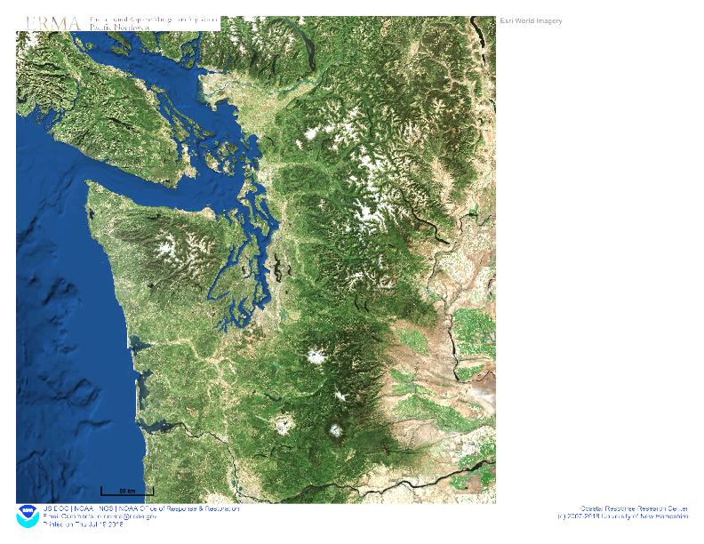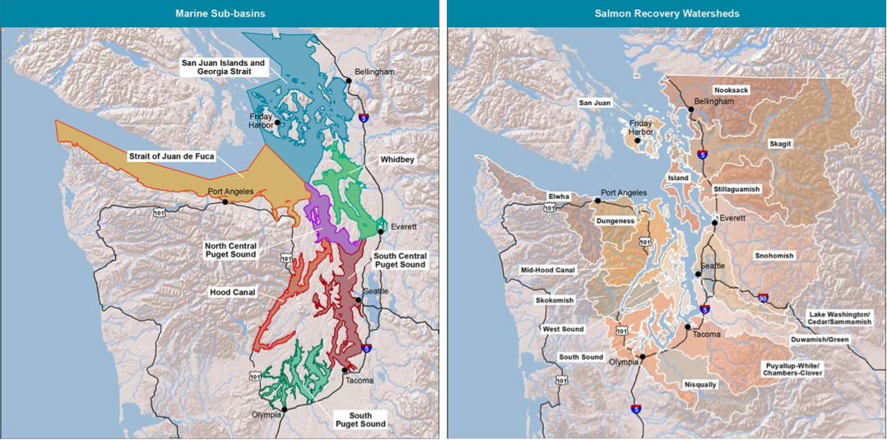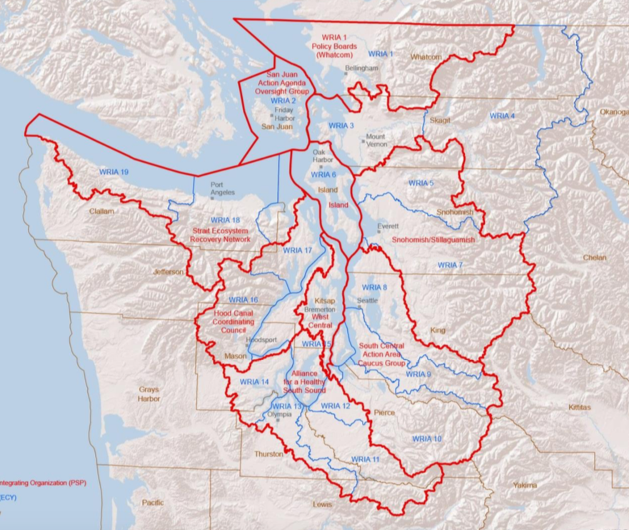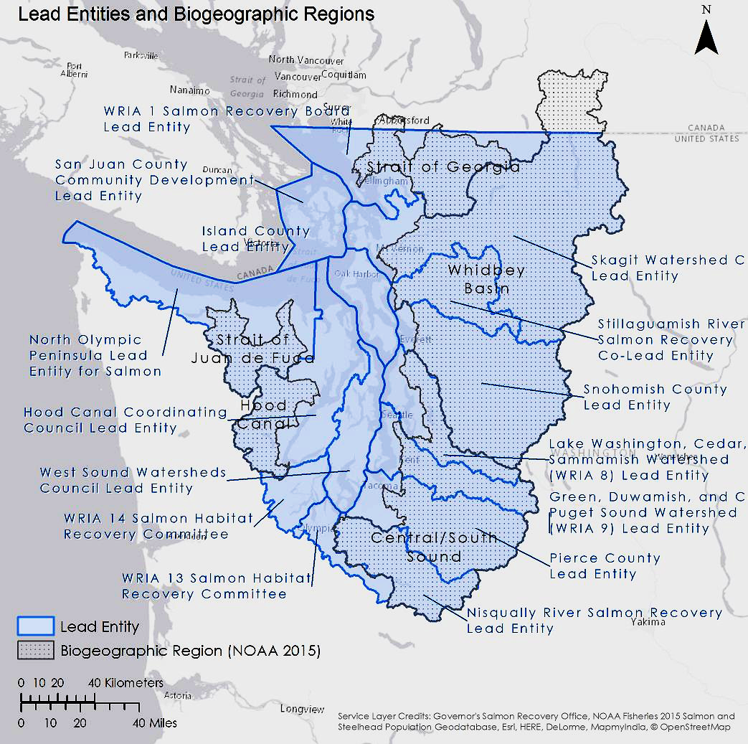

Salmon recovery units

LIOs (red) & WRIAs (blue)

PSPA Units